Ryan Frank
DSC680
01/18/2025

Course Project 1

Problem Statement
One of the biggest concerns with starting a career is determining what your earning potential will be. I would like to analyze and predict income for an individual based on factors that they can choose. These factors would include where they work, where they live, education, occupation, and so on. I think something like this could be a tool used by guidance counselors in high schools to provide ideas to students on impact on the choices they make and the impact it will have on their future earnings.

Data Explanation
My starting point is an extract of American Community Surveys data (collected by the US Census Bureau) for 2024 from usa.ipums.org. This extract contains information on 3,422,888 individuals.
As I am looking to model impacts on income, I have chosen the following information to extract. For geographic data I have taken Census Region, State Identifier (ICPSR and FIPS codes, County Identifier (ICPSR and FIPS codes), Metropolitan status and Metropolitan Area for each sample. For individual information I have gathered number of own children in household, sex, age, marital status, citizenship status, ability to speak English, school attendance status, educational attainment, and field of degree. Finally for employment and income data I selected employment status, labor force participation status, occupation and industry of employment, weeks worked last year, usual hours per week worked, wage and salary income, and state and county of place of work.

Methods
Income is reported as over the entire year, however this does not mean that the individual was working for the entire year. To get a better value for individual income, I had some additional steps to add. I filtered out any respondents that reported less than 32 hours worked in a usual week (this is the standard definition of full time employment in the United States). I also removed records for individuals who did not work for the entire year, as I found reporting on that group to be highly inconsistent and attempting to extrapolate that information to a full year was highly inconsistent. As education and location are key parts of my model, I also cleaned up records where that information was not available.
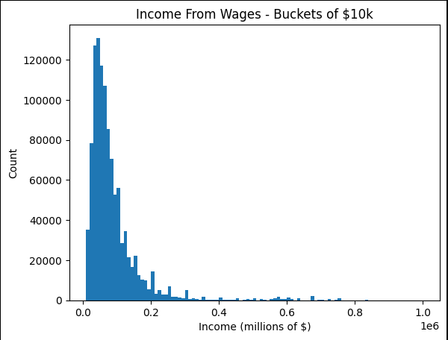
Distribution of income shows a long tail on the right, which I will also need to remove outliers for.

Analysis
As part of my assumptions is educations influence on income I did check on the relationship between the two.
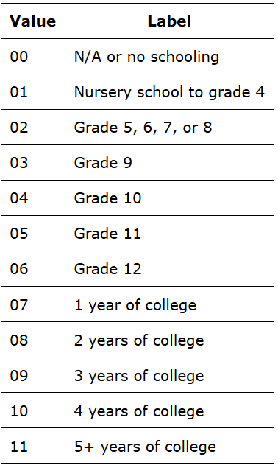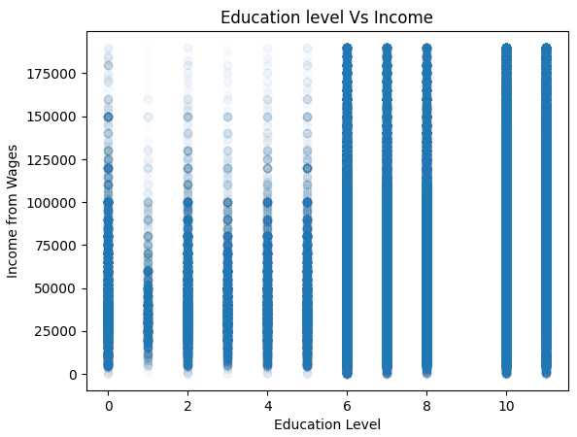
This plot is the coded education level, accompanied by a reference for what the educational attainment value means. While all educational levels have a wide range of income values in the data, there is a definite trend in seeing higher income ranges in the higher education buckets. In particular, graduation from high school and a 4-year college degree show distinctly different patterns. This supports my use of data for my model, however additional details need to be worked out. I also leveraged the scipy package to test the Pearson correlation coefficient for education attainment and found it to be statistically significant (the p-value was less than 0.001).

Final model factors
The following fields were used in the final model
- Income (as the dependent variable)
- Age (Standardized with scipy StandardScaler)
- Education Attainment (standardized with scipy StandardScaler)
- Calculated field for if the respondent has children in the household
The following fields were turned into a series of dummy variables as they are categorical
- State
- Sex
- Metropolitan Area
- Marital Status
- Field of degree (if attended college)
- Industry worked in
- Occupation worked at
American Community Survey Data 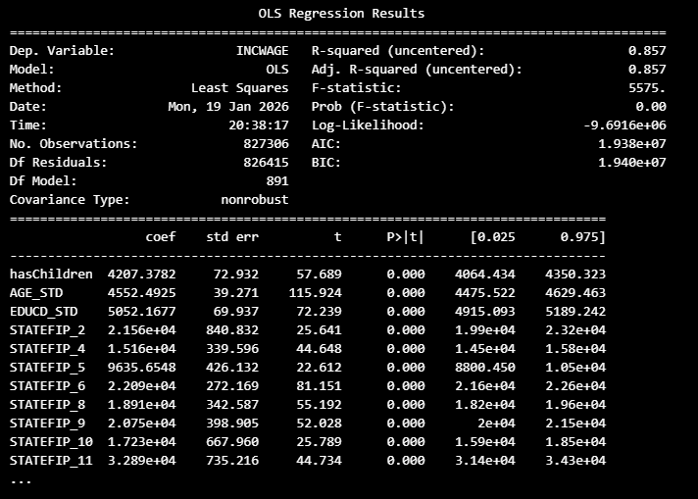The model shows a high R-Squared value (0.858), indicating that ~86% of the variation in wage income is accounted for. The p-value for almost all the features shows up on the summary as zero, indicating that they are statistically significant.

Conclusion
The model does help predict income based on the features provided. There is additional room to improve the model, although I did not discover any additional features or non-linear relationships that could improve the model.

